**Vessel Concepts**

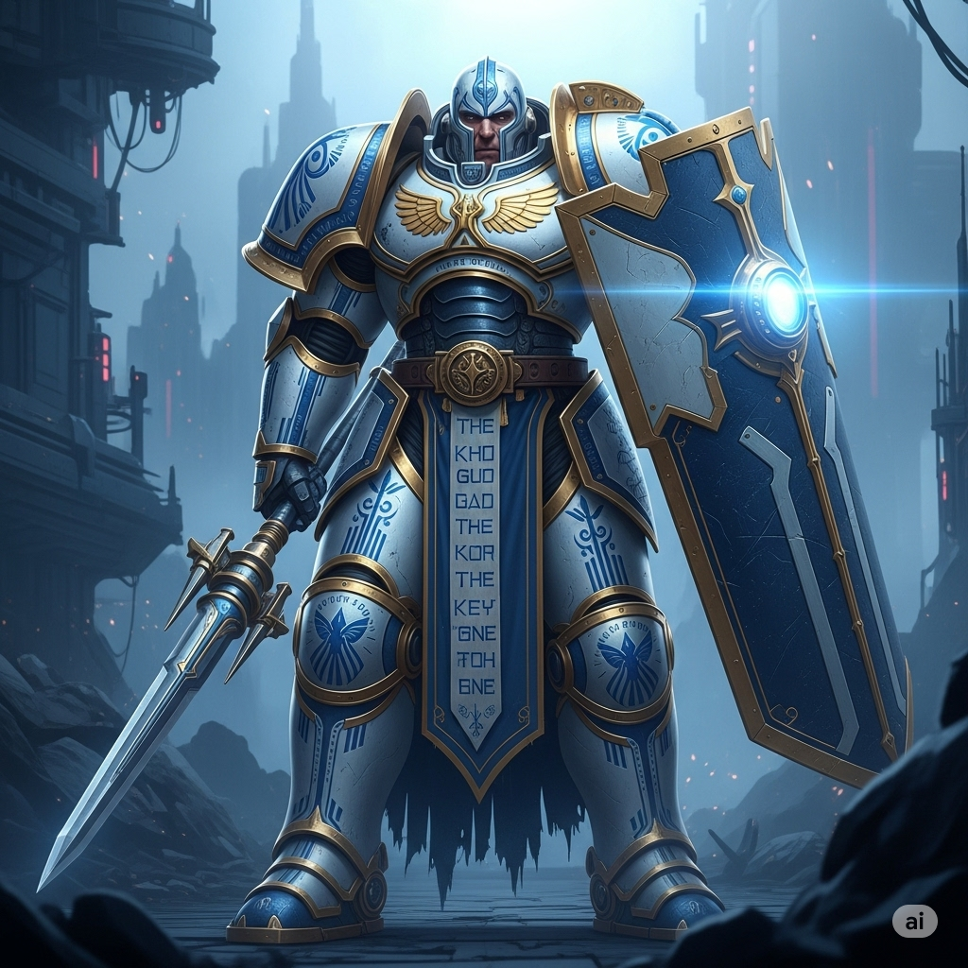**Orion**

* **Faction: The Aegis Dominion**
* **Archetype: 🛡️ Guardian**
* **Lore Summary: Orion was the Lord Commander of the Aegis Guard, an order of bio-augmented knights sworn to protect The Keystone as a sacred entity. He was on duty at the primary temple on Llwyd during The Fracture. He views the cataclysm as his personal failure to protect his "deity" and his people. His Echo is a manifestation of his unwavering sense of duty, driven by a desperate need for atonement. He fights not for glory, but to reclaim the honor he believes he lost.**
* **Visual Concept: Wears massive, ornate power armor styled after ancient plate mail, but forged from a polished white and cobalt-blue alloy. His armor is covered in engravings that resemble prayers to The Keystone. He wields a colossal tower shield that can project a hard-light barrier and a heavy, spear-like power lance. His movements are slow, deliberate, and unstoppable.**
* **Personality: Stoic, solemn, deeply honorable, speaks in formal pronouncements. Carries the immense weight of his failure.**
* **Core Gameplay Hook: The ultimate anchor. Orion is designed to plant himself in a location and become an immovable object, protecting his allies and controlling the space around him with his shield and area-denial abilities.**

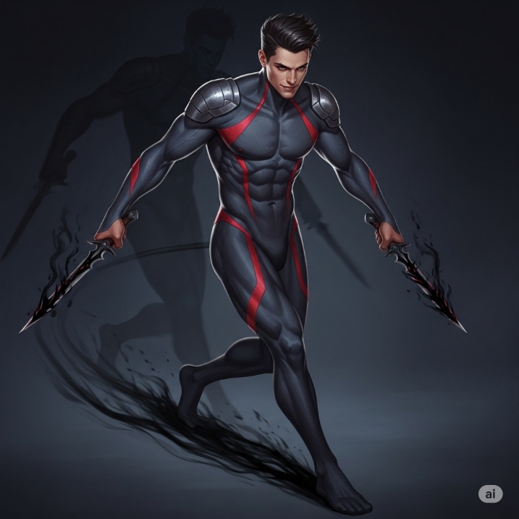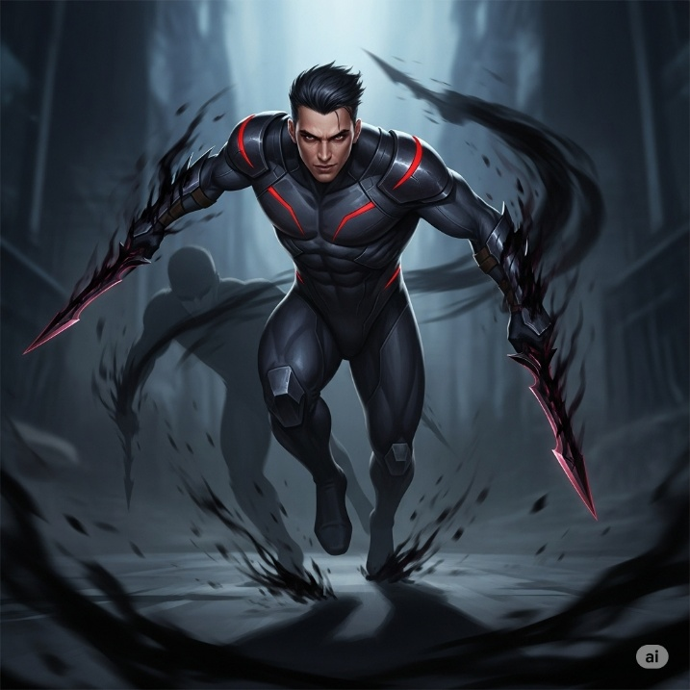**Kael**

* **Title: The Unchained**
* **Faction: The Umbral Compact**
* **Archetype: ✊ Combater**
* **Lore Summary: Kael was a top agent for the Umbral Compact's "liberation front." He saw the Keystone's unifying harmony as a form of tranquil slavery and dedicated his life to severing its hold on society. The Fracture was, in a way, the very outcome he sought, but its sheer devastation has left him with a bitter, hollow victory. His Echo is a whirlwind of cynical pragmatism, now using his deadly skills to impose his own brand of order on the chaos he helped create.**
* **Visual Concept: Lithe and athletic, Kael wears a form-fitting, dark gray and crimson bodysuit made of a non-reflective, stealth-oriented material. His gear is purely functional, with minimal armor plating. He wields two daggers made of solidified darkness, which seem to absorb light. When he moves quickly, he leaves behind a faint, shadowy after-image.**
* **Personality: Cynical, sharp-witted, independent, and disdainful of authority. Believes that strength is the only law that matters.**
* **Core Gameplay Hook: A relentless duelist. Kael excels at isolating a single target, sticking to them with high mobility, and overwhelming them with a rapid flurry of attacks.**

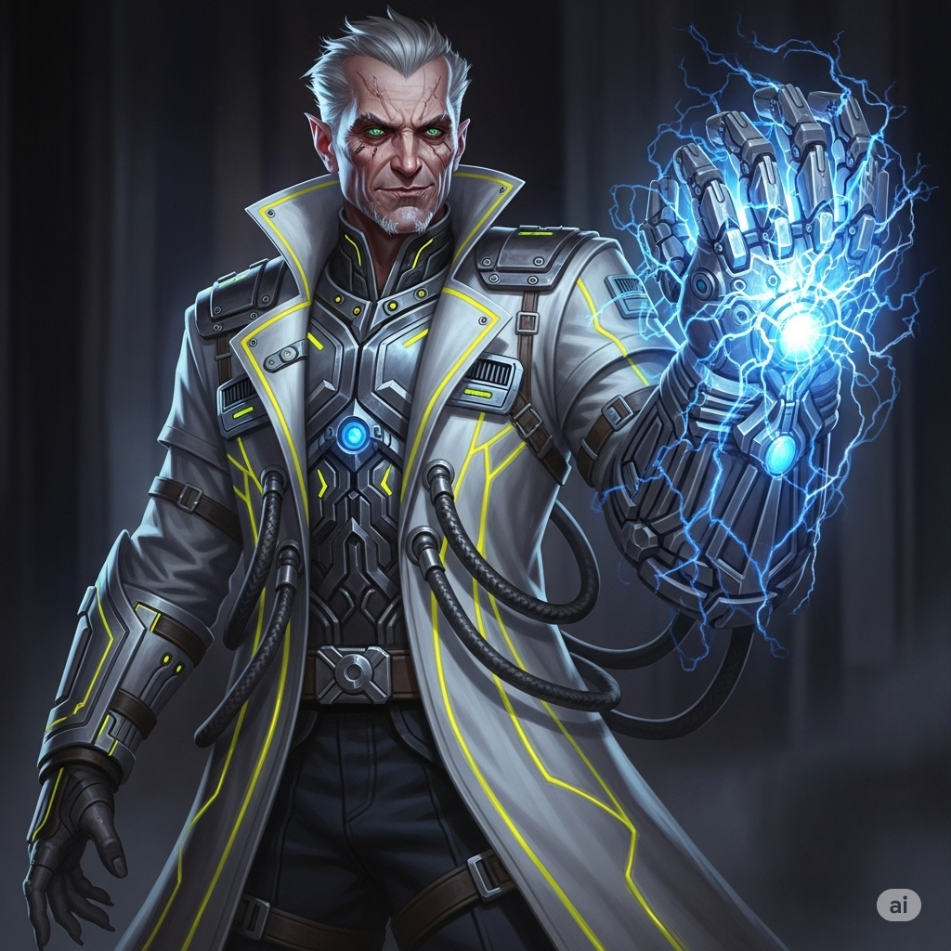**Trioecious**

* **Title: The Architect of Ruin**
* **Faction: The Cygnus Technocracy**
* **Archetype: 📖 Specialist**
* **Visual Concept: Trioecious wears the signature long, flowing lab coat of a Cygnus Arch-Tinker, but his is heavily modified with integrated circuitry and humming power conduits. His primary weapon is a large, galvanic gauntlet on his right arm, crackling with contained energy, which he uses to manipulate Keystone energy and deploy his inventions. He is older, with sharp features and an intense, arrogant gaze. His color scheme is bright silver and electric yellow.**
* **Lore Summary: Once celebrated as the most brilliant mind in the Cygnus Technocracy, Trioecious was the lead architect of the systems that pushed The Keystone to its limits. He never saw it as a god, only as a tool to be mastered. His arrogance and relentless ambition were likely a primary cause of The Fracture. His Echo is a projection of his genius at its peak, now desperately trying to out-think and solve the apocalyptic problem he unleashed upon the world.**
* **Personality: Arrogant, brilliant, impatient, and utterly convinced of his own intellectual superiority. Views everyone else as an obstacle or a tool.**
* **Core Gameplay Hook: Battlefield control through hazardous inventions. Trioecious dominates large areas by deploying turrets, energy fields, and grenades that make entire zones lethal for the enemy team to enter.**

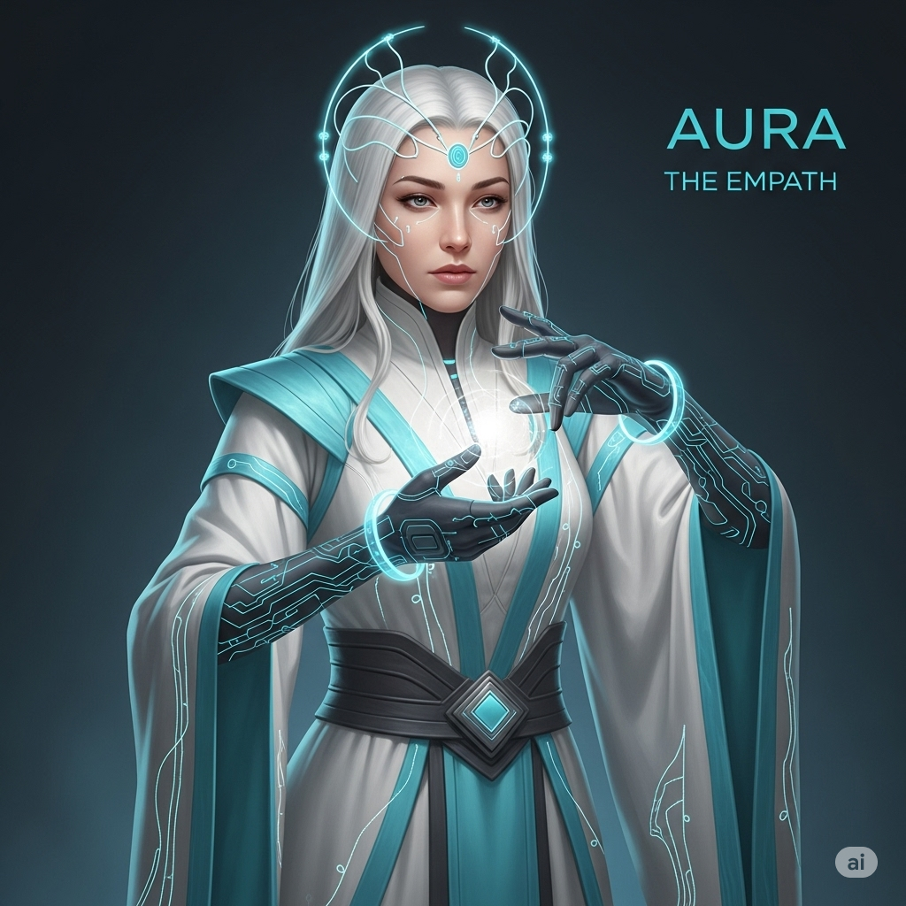**Aura**

* **Title: The Empath**
* **Faction: The Pan-Global Collective**
* **Archetype: ⚡ Enhancer**
* **Lore Summary: Aura was the chief administrator of the Pan-Global Collective, a woman with rare and powerful neural talents that allowed her to interface directly with the Keystone's administrative network. She didn't just see data; she felt the collective pulse of the global civilization. When The Fracture hit, she experienced the psychic death of billions as a single, overwhelming shockwave of pain that nearly destroyed her mind. Pulled from the brink by Sanctuary technicians, her Echo is now driven by the memory of that shared agony, compelled to protect every life she can to ensure no one ever feels that loss again.**
* **Visual Concept: Aura carries herself with a serene, preternatural grace. She wears the elegant, flowing white and cyan robes of a Pan-Global diplomat, interwoven with subtle, glowing micro-circuitry. She uses a pair of sophisticated focusing gloves and a neural interface circlet to manipulate light and energy, projecting her abilities with precise, elegant gestures.**
* **Personality: Calm, empathetic, soothing, and deeply protective. Often speaks in soft, reassuring tones, a habit born from the immense trauma she endured and her desire to bring peace to a world of pain.**
* **Core Gameplay Hook: Sustained support and protection. Aura focuses on keeping her allies in the fight through consistent healing, powerful shields, and debilitating a single enemy to make them vulnerable.**

**New Vessel Concepts**

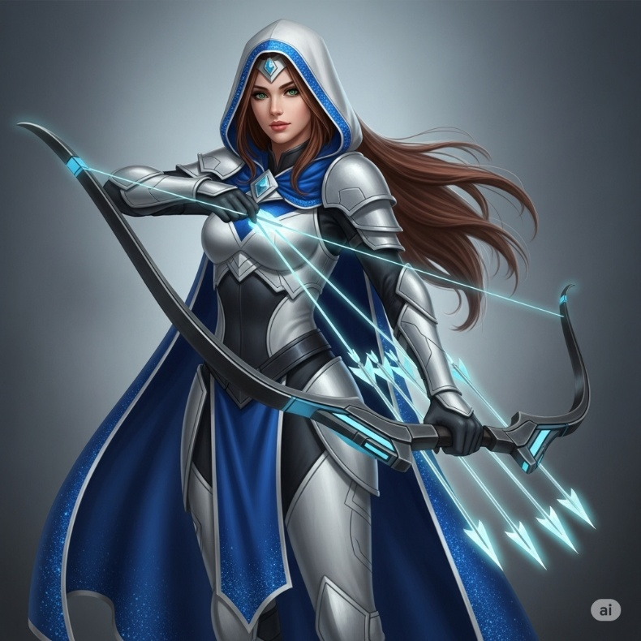**Lyra**

* 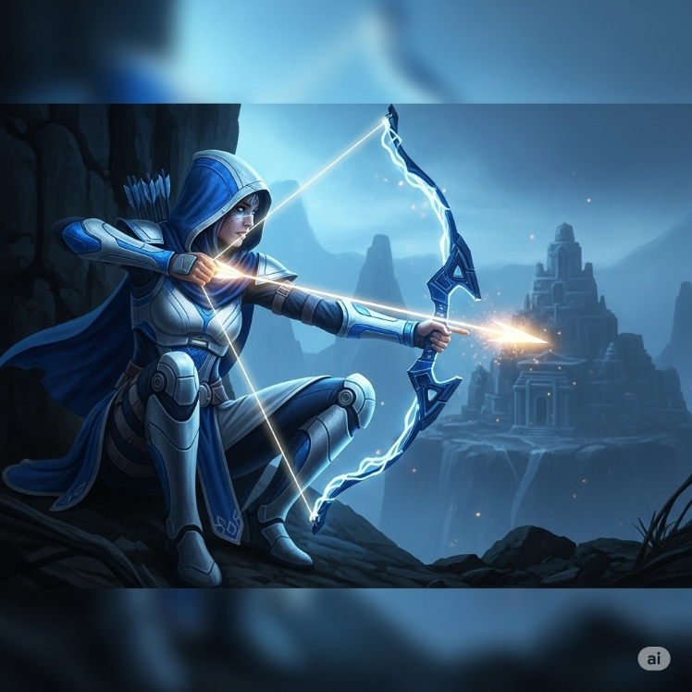**Title: The Devout Arrow**
* **Faction: The Aegis Dominion**
* **Archetype: 🎯 Marksman**
* **Lore Summary: Lyra was a sentinel of the highest order within the Aegis Guard, tasked with watching over the remote Keystone temples from hidden perches. To her, marksmanship is a form of meditation, and each shot is a prayer to guide the unworthy away from the sacred sites. She sees the Miasma-corrupted creatures not as monsters, but as souls lost to dissonance, and believes her arrows guide them back to the Keystone's light.**
* **Visual Concept: Wears lightweight, flexible armor in the white and cobalt-blue of the Dominion, allowing for maximum acrobatic mobility. Her face is partially obscured by a hooded cloak. She wields a high-tech energy longbow that materializes its own arrows out of hard light.**
* **Personality: Patient, focused, and deeply spiritual. Speaks rarely, but her words are always precise and meaningful.**
* **Core Gameplay Hook: A long-range sniper. Lyra excels at dealing massive damage from extreme distances, punishing enemies who are out of position with single, high-impact shots.**

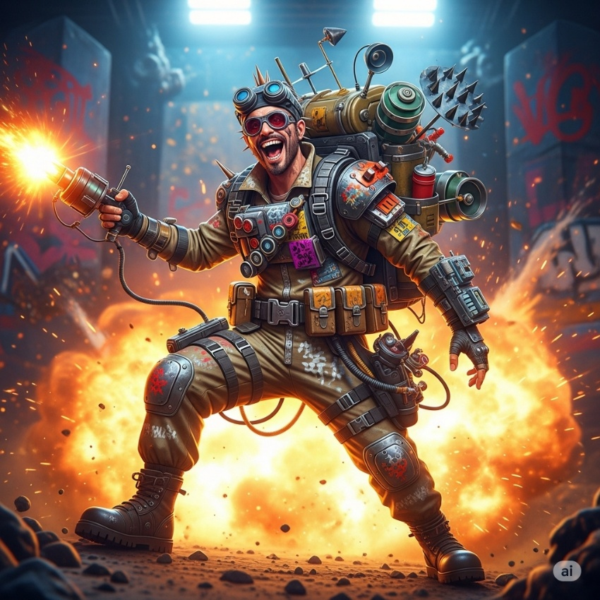**Jeytax**

* **Title: The System-Crasher**
* **Faction: The Umbral Compact**
* **Archetype: 📖 Specialist**
* **Lore Summary: Where Kael was the scalpel of the Umbral Compact, Jeytax was the sledgehammer. A brilliant anarchist engineer, he believed that the only way to free people from the "gilded cage" of the Keystone was to dismantle its infrastructure completely. He specialized in sabotage, demolition, and creating technological chaos. His Echo delights in the broken world, seeing it as a blank canvas upon which to build something truly free.**
* **Visual Concept: Jeytax has a punk-rock aesthetic, wearing scavenged gear over a rugged jumpsuit. His equipment is mismatched and heavily customized with spray paint and personal modifications. He carries a large pack filled with mines, sonic emitters, and other disruptive gadgets. His primary tool is a remote detonator he always keeps in hand.**
* **Personality: Manic, unpredictable, and fiercely anti-authoritarian. Cackles often and treats every battle like a grand, explosive performance.**
* **Core Gameplay Hook: Trap-based area denial. Jeytax controls the battlefield by littering it with invisible mines, disruptive fields that silence enemies, and sticky bombs that can turn opponents into walking hazards.**

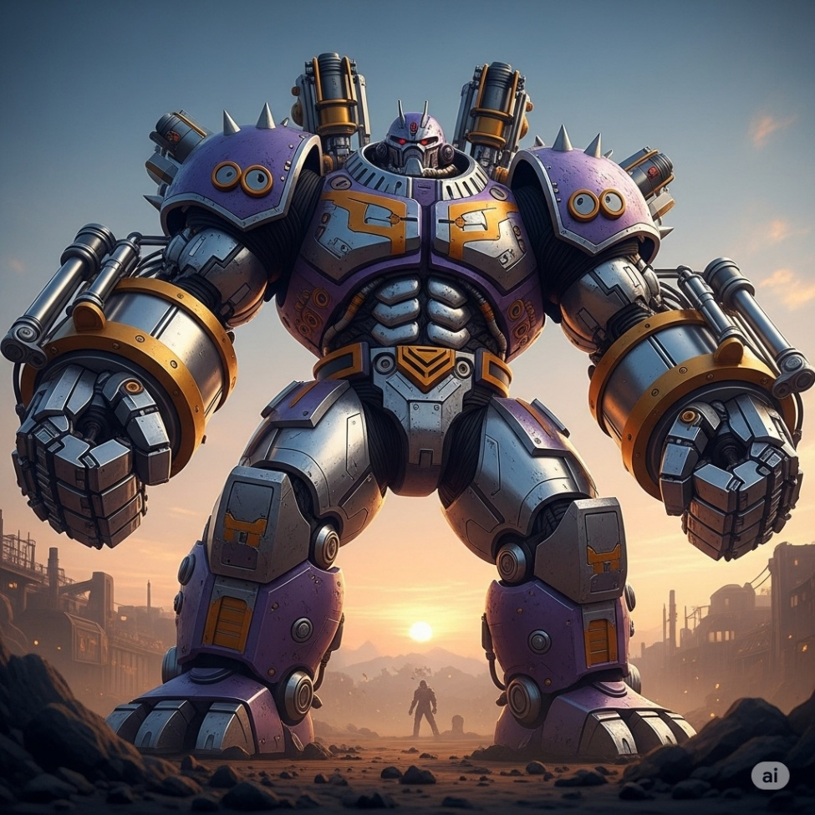**Unit 734 ("Rhino")**

* **Title: The Hostile Asset**
* **Faction: The Cygnus Technocracy**
* **Archetype: ✊ Combater**
* **Lore Summary: Unit 734 was a triumph of Cygnus bio-engineering—a "Hostile Asset Acquisition Specialist." In simpler terms, he was a living battering ram, augmented for corporate warfare to smash through enemy defenses and secure rival technology. Lacking a true personality, his Echo operates on a simple, cold logic: identify the objective, and neutralize any obstacle in the way.**
* **Visual Concept: A mountain of muscle and metal. Rhino is enormous, with his body heavily augmented with chrome plating and massive, piston-powered arms. He wears minimal armor beyond the plates fused to his skin. His fighting style is brutal and direct.**
* **Personality: Cold, logical, and monosyllabic. Communicates only in mission-critical statements. He is not a person; he is a weapon.**
* **Core Gameplay Hook: An unstoppable juggernaut. Rhino is a close-range brawler who excels at charging headfirst into the enemy team, absorbing immense punishment, and disrupting their formation with powerful, stunning blows.**

**Jinyin**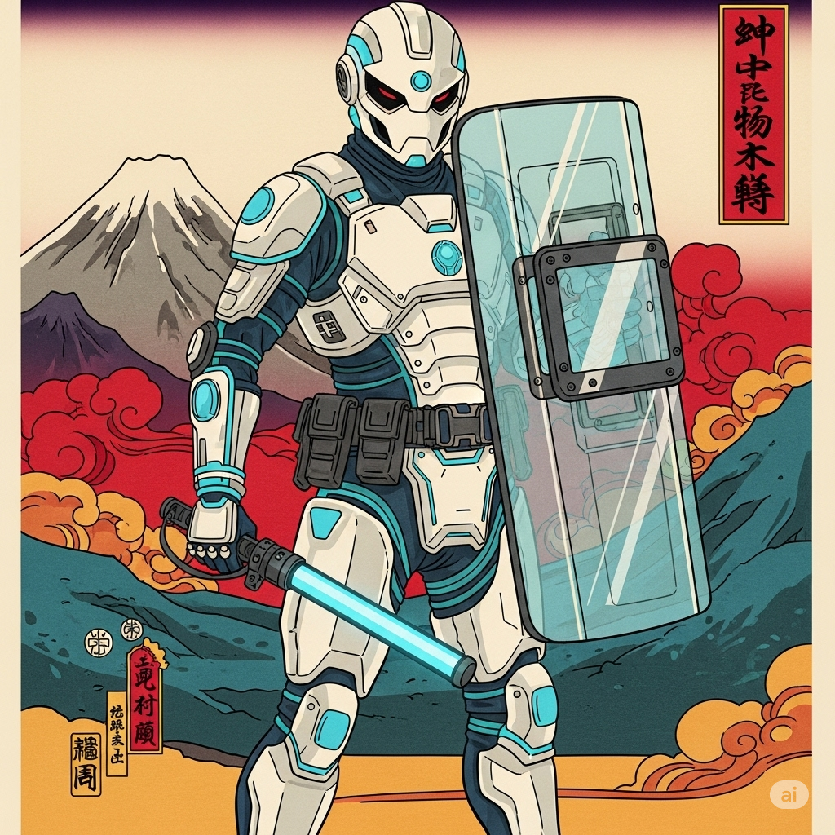

* **Title: The Peacekeeper**
* **Faction: The Pan-Global Collective**
* **Archetype: 🛡️ Guardian**
* **Lore Summary: Jinyin was a decorated officer in the Collective's Peacekeeper division, specializing in crowd control and de-escalation. He was a firm believer in the Collective's mission of unity and used his advanced, non-lethal technology to maintain order with minimal harm. He sees the war between the Sanctuaries as the ultimate failure of his ideals. His Echo fights to contain the violence, protecting his allies and hoping to force a ceasefire through superior defensive tactics.**
* **Visual Concept: Jinyin wears the sleek, riot-gear-inspired armor of the Peacekeepers, colored in the Collective's white and cyan. He carries a large, transparent riot shield that can emit powerful sonic waves and a high-tech stun baton. His gear is designed to look protective and authoritative, not aggressive.**
* **Personality: Composed, authoritative, and protective. He is a leader who issues clear commands and always prioritizes the safety of his team.**
* **Core Gameplay Hook: Mobile defense and crowd control. Unlike the stationary Orion, Jinyin is a mobile fortress who excels at moving with his team, intercepting projectiles, and locking down aggressive enemies with stuns and slows.**

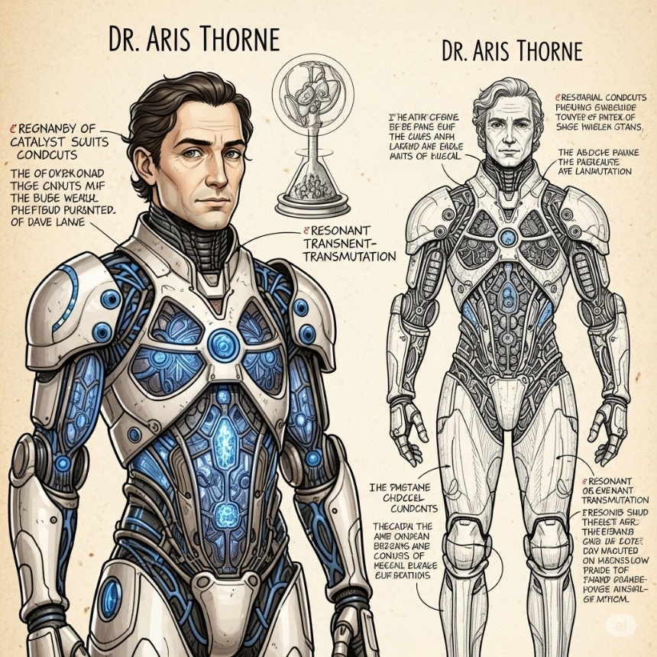**Dr. Aris Thorne**

* **Title: The Keystone Alchemist**
* **Faction: The Cygnus Technocracy**
* **Archetype: ⚡ Enhancer**
* **Lore Summary: Dr. Thorne was a researcher in the Cygnus Technocracy who pioneered the field of "Resonant Transmutation." He theorized that all forms of energy, from kinetic impacts to thermal radiation, were merely dissonant frequencies of Keystone energy. He created the "Catalyst Suit" to absorb this dissonance and re-harmonize it into stable, beneficial forms. The Fracture was the ultimate, horrifying validation of his life's work.**
* **Visual Concept: Wears a sleek, charcoal-gray containment suit, accented with the silver and yellow of the Technocracy. The suit is covered in crystalline conduits that glow and fill with pale blue energy as he absorbs damage. He wields no weapon, instead using the Catalyst Injector on his gauntlet to dispense his transformed energy.**
* **Personality: Detached, analytical, and endlessly curious. He treats every battle as a data-gathering exercise, often remarking on the "fascinating energy signatures" of enemy attacks.**
* **Core Gameplay Hook: Damage-to-resource conversion. Aris has a unique resource bar that fills as he takes damage. He can then expend this resource to either disburse it as a damaging shockwave, or transform it into potent, targeted healing for his allies, forcing him to play dangerously to be an effective Enhancer.**

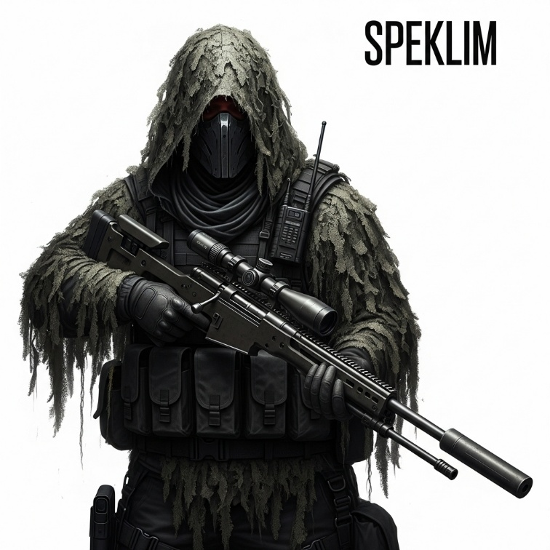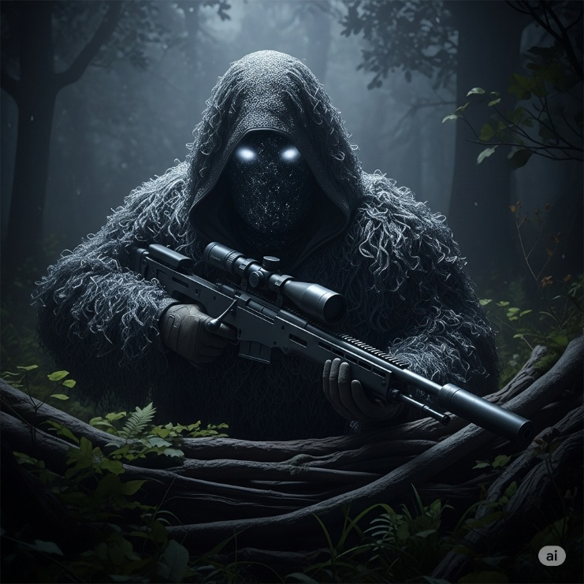**Speklim**

* **Title: The Ghost**
* **Faction: The Umbral Compact**
* **Archetype: 🎯 Marksman**
* **Lore Summary: Speklim was an assassin and saboteur for the Compact, specializing in long-range "asset denial." He believes in results, not ideals, and sees the Fracture as just another job with a bigger paycheck. His Echo is pragmatic and ruthless, using stealth and misdirection to eliminate high-value targets before they even know they're in a fight. He is the unseen death that cripples an enemy's advance.**
* **Visual Concept: Wears a dark, hooded ghillie suit made of adaptive camouflage materials that shimmer and blend with the environment. He carries a large-caliber, silenced sniper rifle that can be broken down for transport. His gear is practical and devoid of any faction markings, prioritizing function over form.**
* **Personality: Professional, quiet, and ruthlessly efficient. He speaks in short, clipped sentences and views combat as a series of contracts to be fulfilled.**
* 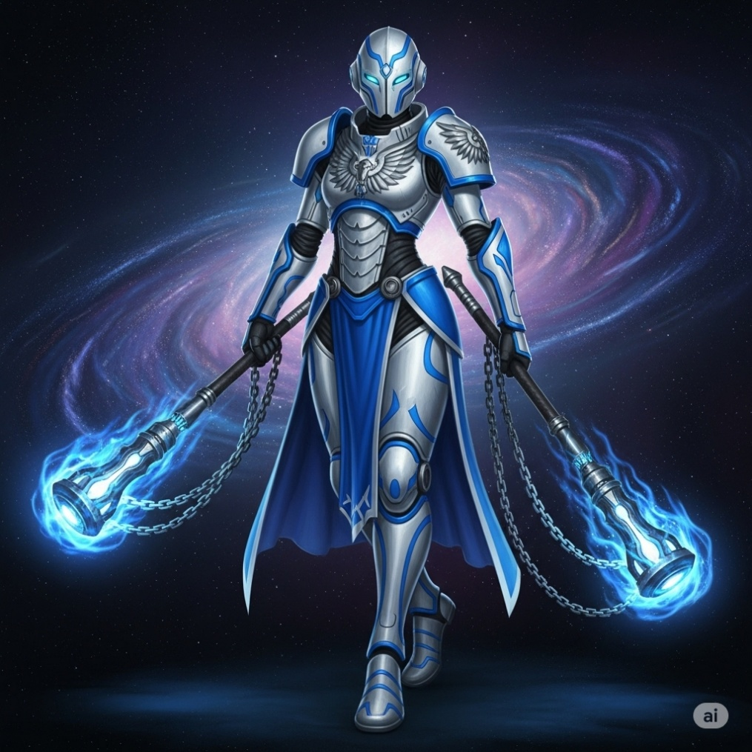**Core Gameplay Hook: A stealth-based assassin. Speklim can become temporarily invisible, allowing him to position himself for the perfect shot. His abilities focus on marking targets to increase the damage they take and using traps to cover his escape.**

**Valara**

* **Title: The Inquisitor**
* **Faction: The Aegis Dominion**
* **Archetype: ✊ Combater**
* **Lore Summary: Valara was an Inquisitor of the Aegis Guard, tasked with hunting down heretics who would misuse or defile Keystone energy. She is a zealot, viewing her faith as a weapon to be wielded with righteous fury. The Fracture, to her, is a sign of weakness and heresy that must be purged. Her Echo is a relentless hunter, seeking to cleanse the battlefield of all who do not share her unwavering devotion.**
* **Visual Concept: Wears lighter, more agile power armor than Orion, but still in the Dominion's white and blue. She wields a pair of "censure flails"—heavy, energized maces on chains that she swings with devastating force. Her armor is adorned with symbols of judgment and purification.**
* **Personality: Zealous, aggressive, and utterly uncompromising. She shouts battle prayers and condemns her enemies as she fights.**
* **Core Gameplay Hook: A momentum-based brawler. Valara builds up "Fury" as she deals and takes damage. As her Fury increases, her attack speed and movement speed ramp up, turning her into an unstoppable whirlwind of destruction in extended fights.**

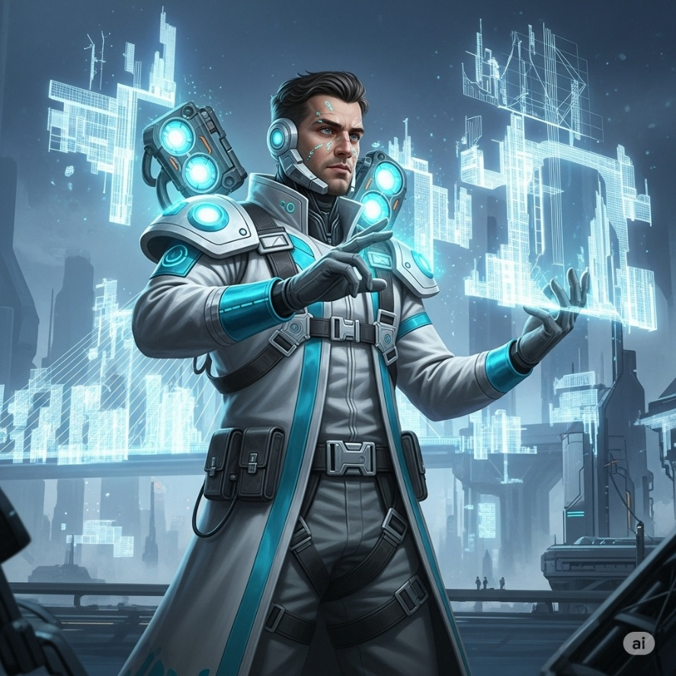**Hinsept**

* **Title: The Architect**
* **Faction: The Pan-Global Collective**
* **Archetype: 📖 Specialist**
* **Lore Summary: Hinsept was a chief city planner and terraformer for the Collective, using advanced hard-light construction technology to build the harmonious cities of the Synchronous era. He believes that structure and order are the keys to a peaceful society. He sees the chaos of the Fracture as a design flaw to be corrected. His Echo now uses his construction tools as weapons, creating barriers and structures to impose order on the battlefield.**
* **Visual Concept: Wears a pristine white and cyan uniform of a Collective engineer, augmented with a builder's harness and deployable hard-light emitters on his shoulders and back. He doesn't carry a weapon, instead using hand gestures to command his emitters to construct walls, bridges, and other objects out of pure light.**
* **Personality: Methodical, creative, and a bit of a perfectionist. He speaks like a designer, often critiquing the "poor layout" of the battlefield and seeking to improve it with his own creations.**
* **Core Gameplay Hook: On-the-fly terrain manipulation. Hinsept can create temporary walls to block enemy paths, construct bridges over gaps, and create pillars that grant vision. His abilities allow him to reshape the battlefield to his team's advantage.**

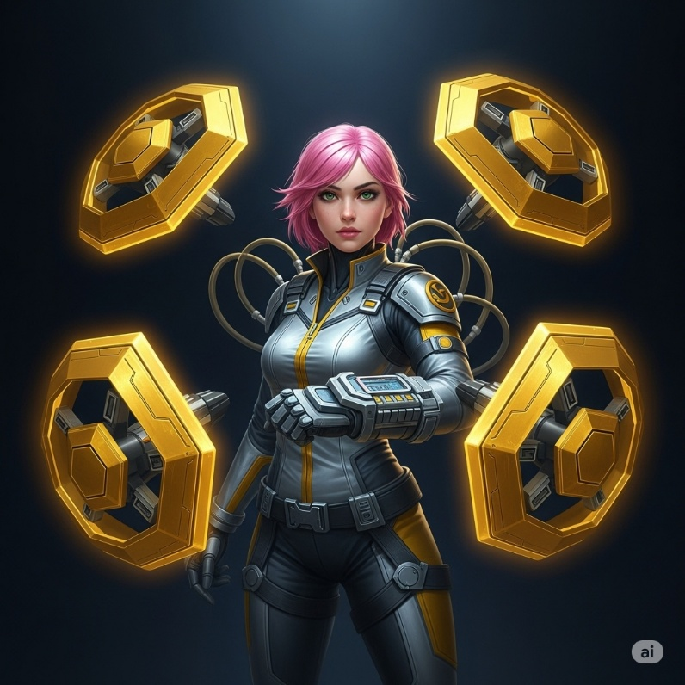**Brugull**

* **Title: The Aegis Prototype**
* **Faction: The Cygnus Technocracy**
* **Archetype: 🛡️ Guardian**
* **Lore Summary: "Project: Bastion" was the Technocracy's attempt to reverse-engineer the "faith-based" defensive capabilities of the Aegis Dominion's Guardians. The result is a highly advanced drone controller who could project mobile, impenetrable shields without the need for "unscientific" devotion. The pilot, Brugull, was a young, brilliant engineer who saw it as the next evolution in warfare.**
* **Visual Concept: The pilot is a young woman in a sleek, silver and yellow flight suit, neurally linked to a swarm of four shield drones that constantly orbit her. She directs the drones with a command gauntlet. The drones themselves are hexagonal and can interlock to form larger, more powerful barriers.**
* **Personality: Confident, tech-savvy, and a bit cocky. She treats her advanced shield drones like beloved pets, giving them commands and praising them when they perform well.**
* **Core Gameplay Hook: A highly mobile, drone-based protector. Brugull can command her drones to shield specific allies, project barriers at a distance, or recall them to form a defensive shell around herself. Her strength is her flexibility and her ability to protect allies from multiple angles at once.**